If you would like to receive this newsletter via email please email your email address to inh@inh.org.au Please put Resident Newsletter as the Subject Title
Welcome
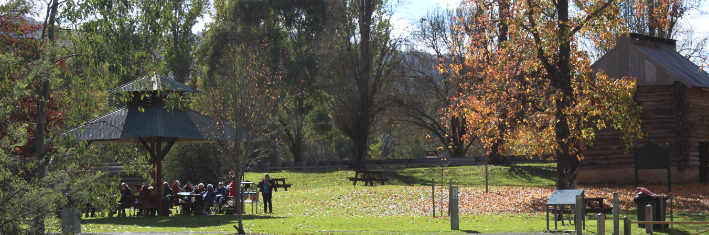
Hello Friends,
Welcome to the May/June issue of the ‘Glenview Grapevine’.
Another busy few months have seen us embracing leisurely pursuits and pastimes despite the cooler weather.
How fortunate we are to have such dedicate, committed volunteers, staff and clients and to be part of such a supportive environment. With the above mentioned being the very key to recent successful events for Indigo North Health.
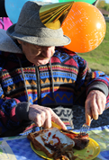
All roads led to the Rutherglen Apex Park recently with the smell of onions, bacon and eggs and tomatoes filling the air for a breakfast feast. The delicious breakfast was cooked by our Catering Team, CEO Shane Kirk and staff, with ingredients kindly donated by ‘Friends of Glenview’. This was a wonderful Annual event bringing all together to enjoy each other’s company and friendship and to show appreciation for everyone’s contribution to our fabulous organisation.

Royal Fever was also in the air recently with the much anticipated Royal Wedding between Prince Harry and Meghan Markle setting the scene for a special occasion.
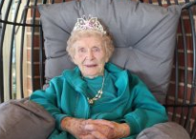
Our ladies had the ‘Markle Sparkle’ donning their Royal finery, beads and tiaras for a Royal High Tea at the Homestead of Wendy Grantham. Guests enjoyed a glass of ‘bubbles’ on arrival and the table was laid with fine china and silverware. A delicious array of home baked biscuits, slices and cakes were served along with tea and coffee. The ‘Queen’ made a surprise guest appearance all the way from Buckingham Palace to quiz us on all things Royal despite her busy schedule. We have ’connections’ here at Glenview. A lovely afternoon was enjoyed by all.
Speaking of High Teas, our residents were once again fortunate enough to be invited to ‘Australia’s Biggest Morning Tea’ with an invitation to join St Joseph’s Primary School in Chiltern for this wonderful event. Money raised aiding Cancer Research and support. Residents enjoyed a lovely morning tea and good company and terrific raffle prizes. We thank St Josephs for their kind invitation.
Our ‘Buds and Blooms’ Program in conjunction with Rutherglen Kinder remains popular with residents enjoying visits to the Kinder to share, stories, song and craft activities. This program gives the residents an opportunity to continue their role as mentors to our young.

We have had plenty of fun kicking up our heels, dancing and warming our hearts and souls with recent entertainment provided by
our dear friends The Wodonga Entertainment Group, Gloria McCluskey and The Corowa Line Dancers.
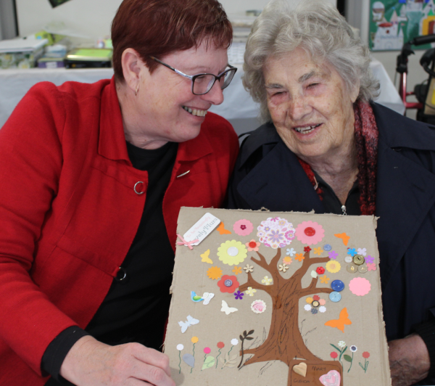
Recently, some of the ladies in our art group were fortunate enough to join in with the artist in residence program at the Yackandandah care facility. The ladies were welcomed into the facility’s lovely recreation room, where they created ‘button’ trees with the help of a group of enthusiastic volunteers.
The visit was designed to provide a taste of the artist in residence program, with a view to developing a similar program here, where residents can explore working in a range of different media and expand their skills to create more diverse art pieces.
The therapeutic benefits of art are widely researched and reported. Volunteers to assist with our art program are always welcome.
Until next time,
Please take care.

Kind regards,
The Leisure and Lifestyle Team.

Chiltern Op Shop

DONATIONS WANTED!!!
Do you have an overflowing wardrobe or unwanted goods?? Make a donation of good quality, clean and reusable goods to Indigo North Health’s Op Shop located on the corner of Conness & Main St, Chiltern. All donations are greatly appreciated!

RESIDENT / REPRESENTATIVE MEETING
To be held on Wednesday the 4th of July
@ 2.00pm in the Dayroom.
All Welcome.

