If you would like to receive this newsletter via email please email your email address to inh@inh.org.au Please put Resident Newsletter as the Subject Title

Hello friends,
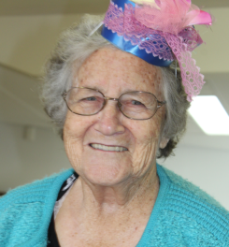
Welcome to the November/December issue of the Glenview Grapevine and our final edition for this year. Hasn’t time flown by!
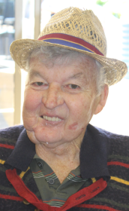
November started in a sea of colour and a party atmosphere with residents enjoying Oaks Day celebrations. The Dayroom was transformed into a race day carnival scene with a race themed corner display by staff member Carol Anderson. Complete with jockey silks, riding boots, race day ladies wear, and even a miniature horse and bottle of champagne to celebrate a win.
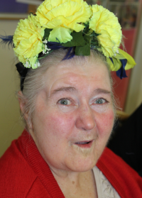
Once again fashions on the field were keenly embraced. Residents donned an array of pretty and colourful hats and fascinators. The Wodonga Entertainment Group kept the crowd entertained, with singing and clapping along to old fashioned musical favourites.
Following the formalities a delicious chicken and champagne luncheon was served.

Remembrance Day saw us welcome our dear friends from the Rutherglen RSL Sub Branch. We remain extremely proud of our association with this special group and were honoured to have them conduct our Remembrance Day service.
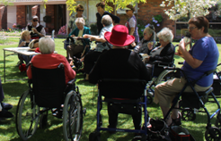
Our residents recently visited a beautiful garden in Oxley. Residents enjoyed a lovely picnic lunch spread out on the lush green lawns in the garden of Lorraine and Graeme Vincent.
Lorraine and Graeme are friends of resident Jean Nichols sisters Lorna and Marg, Jean’s sisters volunteer with our water exercise program. We enjoyed sitting under the shady trees and strolling through the three acre garden that came into bloom just to meet us.
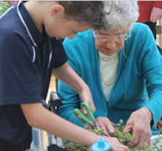
Children from Rutherglen Primary having been assisting us with our ‘Garden Gurus’ program on a fortnightly basis and residents have enjoyed potting up plants and sharing their gardening knowledge together in our sensory garden on the balcony. Children have also share their love of books by reading and sharing stories with our residents.
The Leisure and Lifestyle would like to take this opportunity to thank staff and volunteers across all areas of Indigo North Health for the dedication and commitment you bring to your role, your friendship and compassion shown to residents, clients and their loved ones.

We also thank you the residents and your loved ones for trusting us with your care. We look forward to continuing our association with you in 2019, as we continue to strive to provide the highest quality of care and positive life experiences for all in our care.
May your Christmas sparkle with moments of love, laughter and good will, and may the year ahead be full of contentment and joy. Have a Merry Christmas.
Kind regards,
The Leisure and Lifestyle Team.
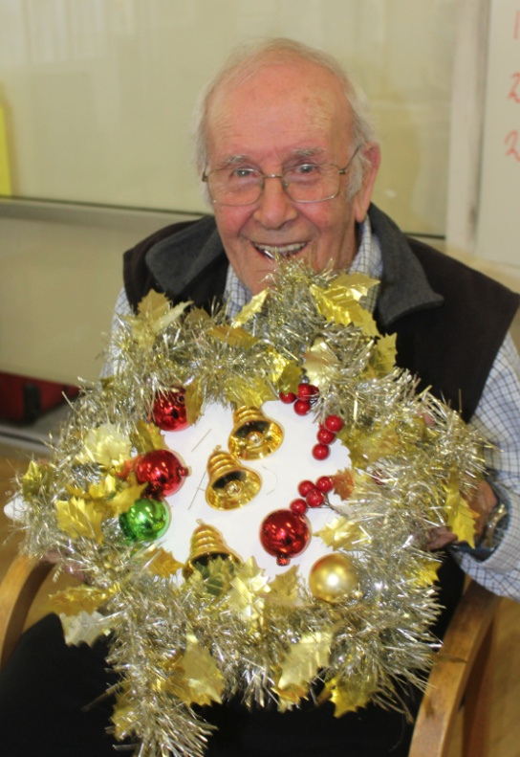
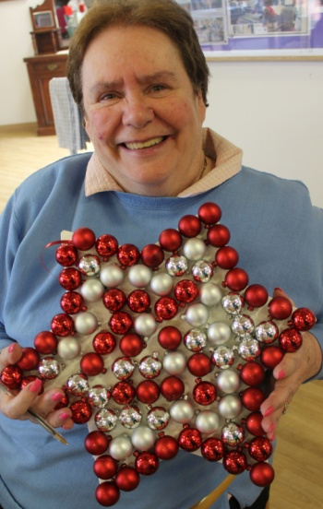
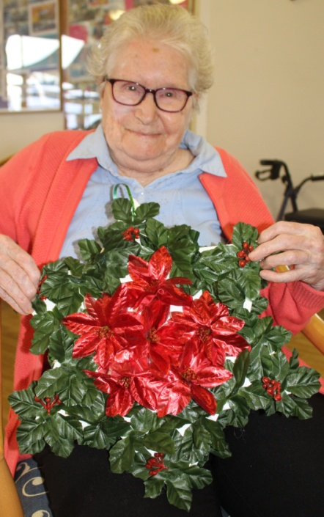

Residents/Representatives Christmas Party Thursday 13th December at 1.30pm.

If families have a gift from Santa for Children attending could they please label it clearly and give to Leisure and Lifestyle Staff - Jo Waring or Belinda Suffern prior to the day.

BIRTHDAYS
DECEMBER BIRTHDAYS:
4TH-TOT NICHOLLS
11TH-TERRY FITZGERALD
11TH-INGO KIRSCH

Reminders

- Due to fire and safety precautions any person who is a visitor to Glenview Residential Aged care must sign the Visitor’s Register upon arrival and departure.
- Please also write the proximity tag no. into the book.
- Quiet time 1.30pm to 2.30pm
- All food donations (includes any food items brought in for a resident) must be registered in the ‘Food Safety Register of Donated Foods’ at reception (read below information)
- Your thoughts and suggestions are values and we would greatly appreciate any customer feedback whether it is a compliment, suggestion or any issue that you may have.

We encourage family and friends to visit residents anytime.

Quiet time is between 1.30pm and 2.30pm daily.
To help us know who is the facility should there be an emergency, please complete the Visitors’ Register located at reception when you arrive and when you leave.

Access to Glenview during business hours Monday to Friday 8.30am-5pm is by the use of a ‘Proximity Key Tag’ located in a basket beside the Visitor’s Register. Please record the ‘Proximity Key Tag’ number in the register.

To enter and exit: WAVE TAG in front of the Proximity Reader (black pad)
Please ensure the door is closed behind you. If doors stay open, use the door release button located on the dividing wall.
Return tag to basket when signing out.
Outside business hours: ring call bell outside entrance to Indigo North Health.

Food Safety Program

Food is handled and prepared, purchased and stored according to the Food Safety program.
Residents, family or friends may bring in food, if the resident prefers. However, foods of high risk such as, poultry, fish, dairy products, meat, eggs, and rice brought in by the resident or family /friends must be consumed at the time of being brought to the facility.

Staff must not store these food items or reheat them. Foods must be stored and transported to the facility in an appropriate temperature controlled container e.g. esky).
Food of low risk such as, biscuits, unfilled cakes, fruit are acceptable to be stored and served.
Any food donated is kept and stored in the dinette refrigerator or cupboards, and not brought into the kitchen. A Register of Food Donated /Brought to the Facility is maintained and located in reception near the sign in register.

Chiltern Op Shop
DONATIONS WANTED!!!
Do you have an overflowing wardrobe or unwanted goods?? Make a donation of good quality, clean and reusable goods to Indigo North Health’s Op Shop located on the corner of Conness & Main St, Chiltern. All donations are greatly appreciated!

RESIDENT / REPRESENTATIVE MEETING
To be held on Wednesday the 5th DECEMBER
@ 2.00pm in the Dayroom.
All Welcome.

.

News items

Staff Member of the Year.

We wish to acknowledge Jennene Doyle was awarded staff member of the year at our Annual General meeting held on 19th November 2018.
Jennene was nominated for her hard work and for going above and beyond the call of duty. Congratulations Jennene on this significant achievement.

Your feedback is important to us.
Our website has been changed to incorporate a distinctive feedback page.
If you would like to leave feedback the direct link to do this is at: http://www.inh.org.au/feedback/ or alternately there are feedback forms located in all areas. Just ask staff if you are unsure where to access.

Glenview Xmas Day Lunch
Bookings Essential
Cost $15 pp
Payment: Can be made prior to the day at reception (preferred) or to nursing staff on the day.

Could you also please advise staff if you are planning on taking a resident home for Xmas day and if so will it be for lunch, dinner or both.

